190905513 LAB 01 MOHAMMAD DANISH EQBAL

LAB EXERCISES:

Write a ‘C’ program

1. To count the number of lines and characters in a file.

Program:

/*To count the number of lines and characters in a file. */
#include <stdio.h>
#include <stdlib.h>
#include <unistd.h>
#include <string.h>
int main(int argc, const char argv[])
{
printf("All the file in the computer\n");
system("ls -l");
FILE *fp;
char fileName[1000];
char ch;
int countLine = 0;
int countCharacter = 0;
int countWord = 0;
printf("Enter the filename from the given list of file: ");
scanf("%s", fileName);
fp = fopen(fileName, "r");
if (fp == NULL)
{
printf("File does not exist\n");
return 0;
}
while ((ch = fgetc(fp)) != EOF)
{
printf("%c", ch);
countCharacter = countCharacter + 1;
if (ch == '\n')
{
countLine++;
}
if (ch == ' ' || ch == '\t' || ch == '\n')
{
countWord++;
}
}
printf("\n");
printf("The Line number is = %d\n", countLine);
printf("All the character in the file are : %d \n", countCharacter);
printf("All words is = %d", countWord);
printf("\n");
return 0;
}

Output:

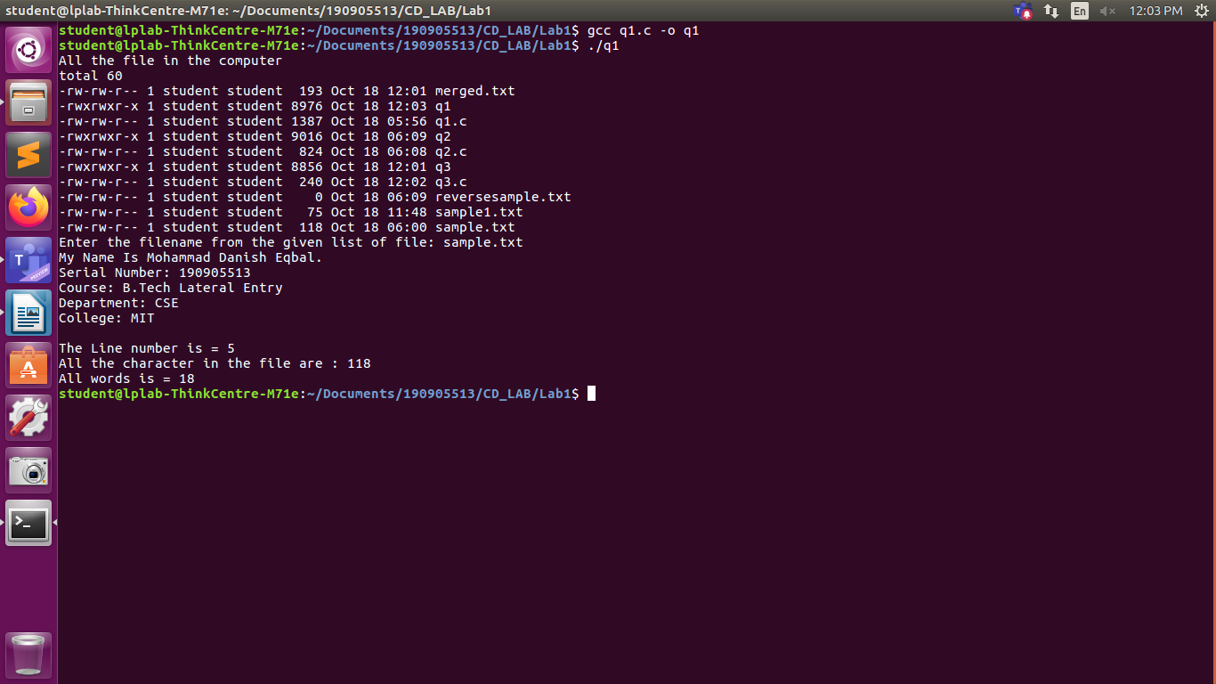

File Sample.txt:
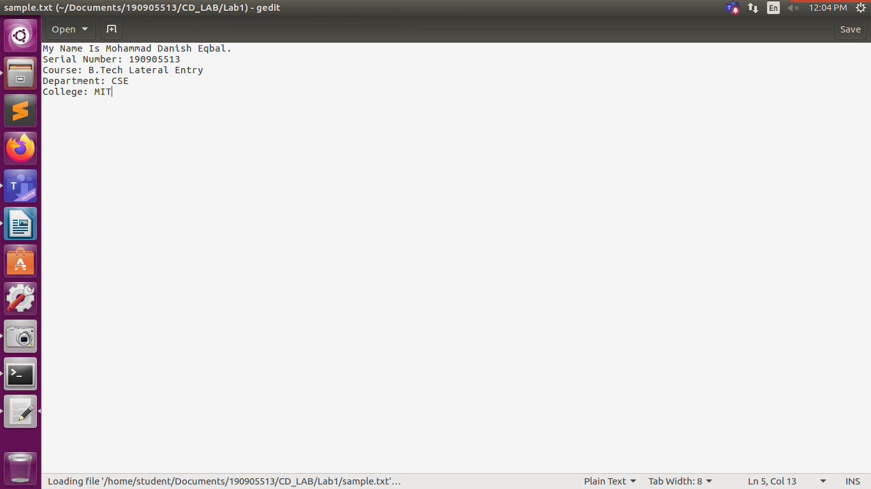
2. To reverse the file contents and store in another file. Also display the size of file using file handling function.

Program:

/*To reverse the file contents and store in another file. Also display the size of file using file handling function.*/
#include <stdio.h>
#include <string.h>
#include <unistd.h>
#include <stdlib.h>
int main()
{
FILE *fp1;
FILE *fp2;
int countSize;
int i = 0;
int ch;
fp1 = fopen("sample.txt", "r");
fp2 = fopen("reversesample.txt", "w");
if (fp1 == NULL)
{
printf("File does not exist ! \n");
return 0;
}
fseek(fp1, 0, SEEK_END);
countSize = ftell(fp1);
while (i < countSize)
{
i++;
fseek(fp1, -i, SEEK_END);
printf("%c", fgetc(fp1));
}
printf("\n");
printf("The size of the file is = %dB\n", countSize);
fclose(fp1);
fp1 = fopen("sample.txt", "r");
fseek(fp1,0,SEEK_END);
while ((ch = fgetc(fp1)) != EOF)
{ fseek(fp1,-i,SEEK_END);
fputc(ch, fp2);
}
fclose(fp1);
fclose(fp2);
return 0;
}

Output:

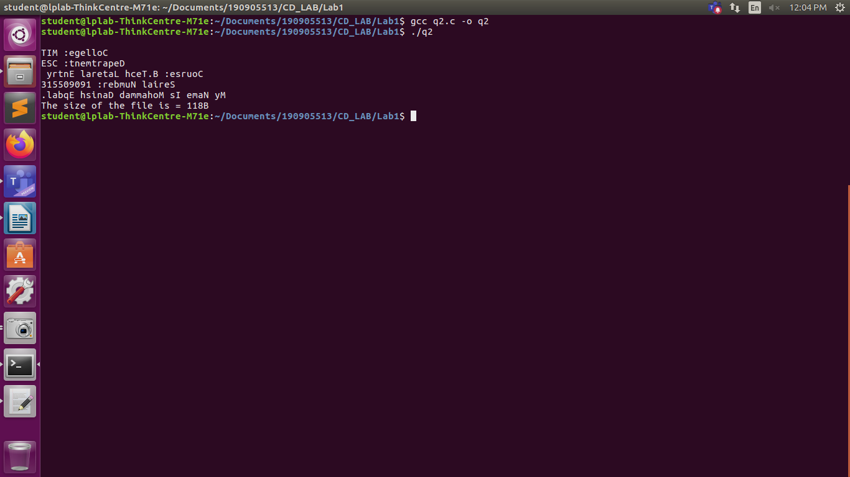

File Sample.txt:

3. That merges lines alternatively from 2 files and stores it in a resultant file.

Program:

4. That accepts an input statement, identifies the verbs present in them and performs the following functions
a. INSERT: Used to insert a verb into the hash table.
Syntax: insert (char *str)
b. SEARCH: Used to search for a key(verb) in the hash table. This function is called by INSERT function. If the symbol table already contains an entry for the verb to be inserted, then it returns the hash value of the respective verb. If a verb is not found, the function returns -1.
Syntax: int search (key)

Program:

